

Flashcards App

Project for Module 226a

Milena Blaser, Blerinë Berisha

AP20a

Table of Contents

Introduction 2

Planning 3

Decisions 4

Implementation 5

Console output 5

# Introduction

The task of this project is to create an app of our liking. We have decided to program a flashcard app, with which you can study.

In the flashcard app, the user can:

* Create a set

🡪 a set can be added, containing flashcards. i.e., French vocabulary set. There can be several sets saved.

* + Add flashcards

🡪 single flashcards with words and their definitions can be added to a set

* + Remove flashcards

🡪 flashcards can be removed from a set

* + Update flashcards

🡪 definition or word of a flashcard can be changed

* Remove a set
* Go through the flashcards
  + Turn them around

🡪 flashcard can be flipped to show the correct answer

* + Swipe left/right (knew it vs. didn’t know it)

🡪 the user can determine whether or not they knew it and swipe accordingly. Swiping left meaning they knew it and swiping right meaning they didn’t know it.

* Go through the flashcards but by writing the answer on their own

🡪 instead of simply flipping and swiping the flashcards, the answers now must be written out and will be corrected by the app itself.

* + Click “I don’t know” button to see answer

🡪 if the user doesn’t know the answer, they can click a button, to see the answer.

* + Check answer

🡪 once the user entered an answer, they can check whether it’s correct. The next step is determined by whether or not the answer they entered is correct.

* + - if correct it goes to the next flashcard. You must get a flashcard correctly twice to have ‘completed’
    - if wrong, the correct answer & spelling will be shown, and the user must repeat the correct answer to move on
* show sets

🡪 shows all sets and the number of flashcards in those sets that have been added by the user.

* + show flashcards of a set

🡪 all flashcards of the set can be seen. They’re shown as a list or table, where we can see the index of the word, the word and the definition of it.

# Planning

We created a GitHub repository fairly quickly, after that, we started with our first class diagram. We brainstormed and wrote down what we needed, which we then put into the diagram.

After the first diagram was created, we started to split up tasks to start.

That way we decided that Milena is going to create the diagrams, while Blerinë gets started on the documentation and creates the base structure for the project.

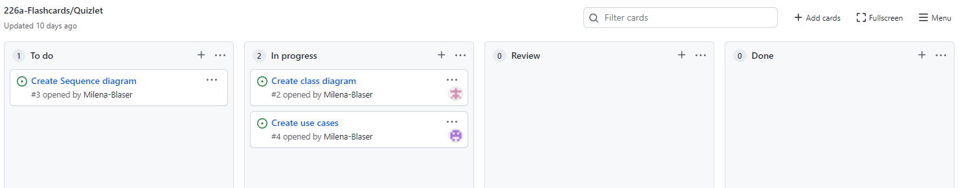

To split the tasks up and make sure we have a good general overview over everything, we created a project in GitHub and opened issues.  
The four columns we created are:

* To do

🡪 Tasks that have to be done for this project, that haven’t been started yet.

* In progress

🡪 Tasks that have been started but aren’t done yet or have been rejected in the “Done” column.

* Review

🡪 Tasks that are done and are currently being reviewed. If there are mistakes or errors, the task will be dragged to “In progress” and the mistakes must be corrected/the task needs improvement.

* Done

🡪 Tasks that are done, have been reviewed and have been accepted.

We kept creating more issues and writing comments, to get a better overview, over what needs to be done in this issue.

# Decisions

We decided not to create a GUI but instead give the user a pretty console output. We wanted to have box outputs, where the menu for example, is displayed in a box, like this:

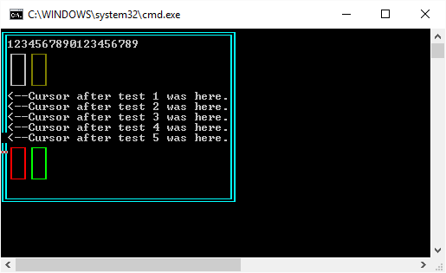

[*Image source*](https://www.codeproject.com/Tips/1091249/Drawing-a-Rectangle-in-the-Csharp-Console)

We also decided early on that we’re going to navigate our whole process and our end goal with the functionalities of Quizlet, i.e., that we’re adding the functionality of having to get the word correct twice to be done with it while practicing, that the user can choose to either flip the cards or learn them by writing them down or that the user can also get the word partially correct.

One thing that we didn’t decide, was whether we want to assign the issues on GitHub. So sometimes they would be assigned and sometimes they wouldn’t be assigned. Although we didn’t decide on that, we communicated and made sure, we weren’t working on the same task and discussed who would work on which issue.

Our methods are nicely split into the classes, in a way which makes the most sense to us, i.e., the QuizManager contains the chooseAction() method where the user can choose what to do in a specific set, Quiz contains the startQuiz() method where the main menu is printed and the user can choose what to do in the very beginning or that Flashcard just consists of attributes, a constructor, getters and setters and has no method that we wrote on our own.

The last thing we decided on early was that we wanted to go on a little bug hunt in our own code (maybe even get some other people on board) and improve the naming once we have all the functionalities and overall improve the code wherever we can.

# Implementation

Something we focused on first, was the base structure. Which means creating the classes we need (Flashcard, Set, QuizManager, Quiz), adding all attributes, constructors, getters and setters.

Later on we realized that we also needed an IOHandler, so we added one, where we have several print methods that are implemented everywhere in the program.

While realizing our idea we focused on functionality and pretty output, resp. a nice overview of what’s happening in the console.

## Console output

A task we saw as optional was to implement different colors for the output.

For example, the user can choose a color and while there are many options, all of them are set, so that the user can read any of them well.

The default color in the program is set to gray and the user can simply enter the number in the braces to choose a color.

Moreover, the method of printing and searching for sets and flashcards has been set to automatically pad the length of the box, by using:

String toPad = manager.getSets().get(i).getTitle();  
String padded = String.*format*("%-30s", toPad);

The second line in this code snippet determines how many characters it should fill out with space on the left or on the right, until the entire “padded” variable reaches 30 characters.

If we had wanted the space to be padded on the left, we would’ve had to use "%30s" instead of "%-30s". To pad on the left side, positive numbers are required, meanwhile padding on the right requires negative numbers.